# Cloning in Git:

1. 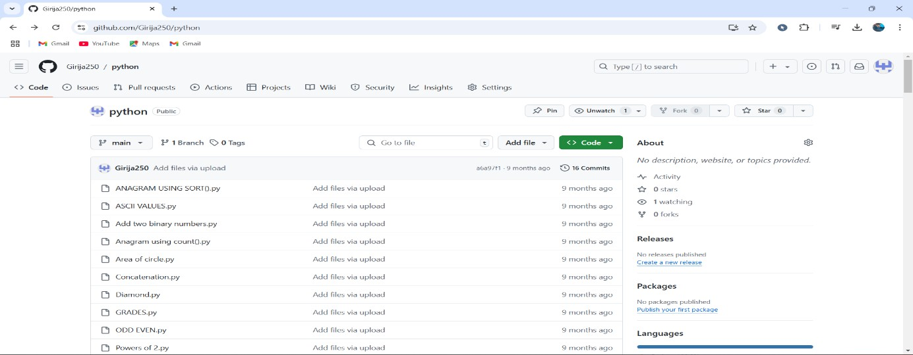Open the existing repository with code in the github account.
2. In the right top corner click the code box and copy the url.

# R Charitha

# 192373007

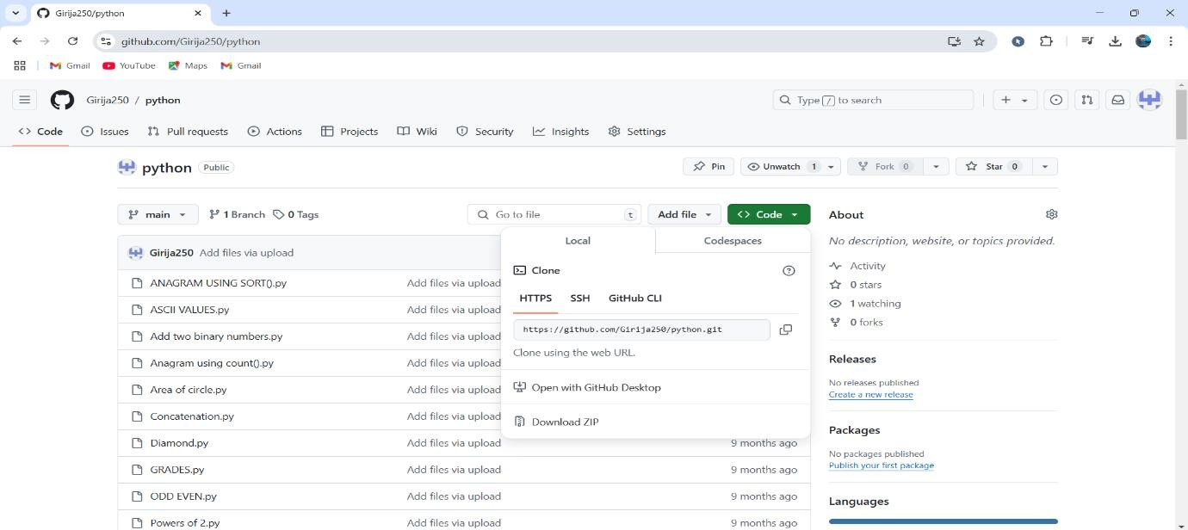

1. In the empty folder click open Git Bash Here.

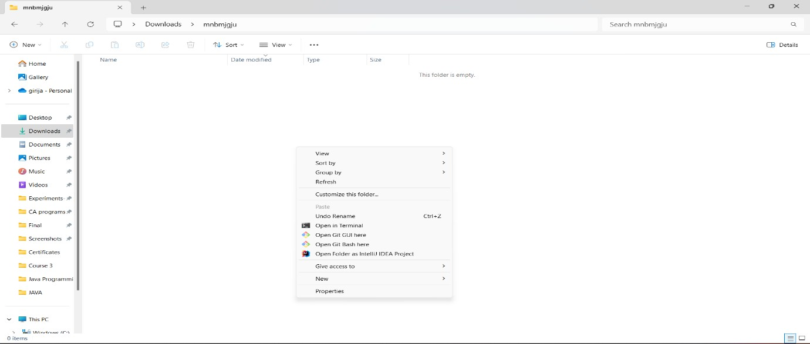

1. 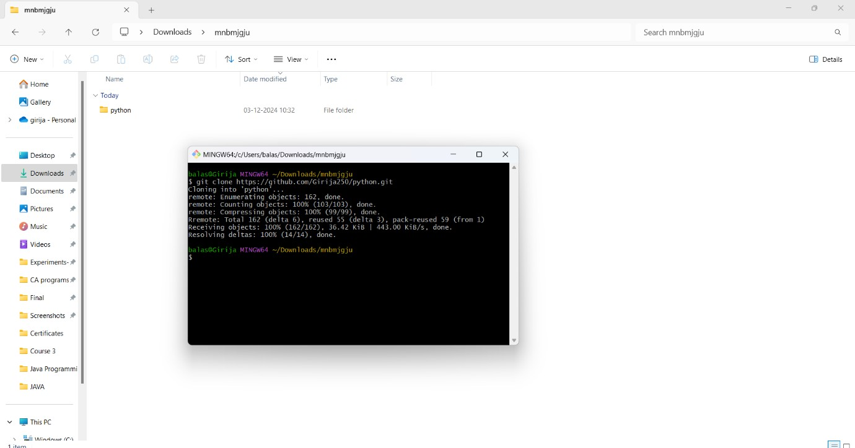Type git clone <url> that was copied from github.You will see the repository copied in this folder.
2. Type git status to view the status of the repository.

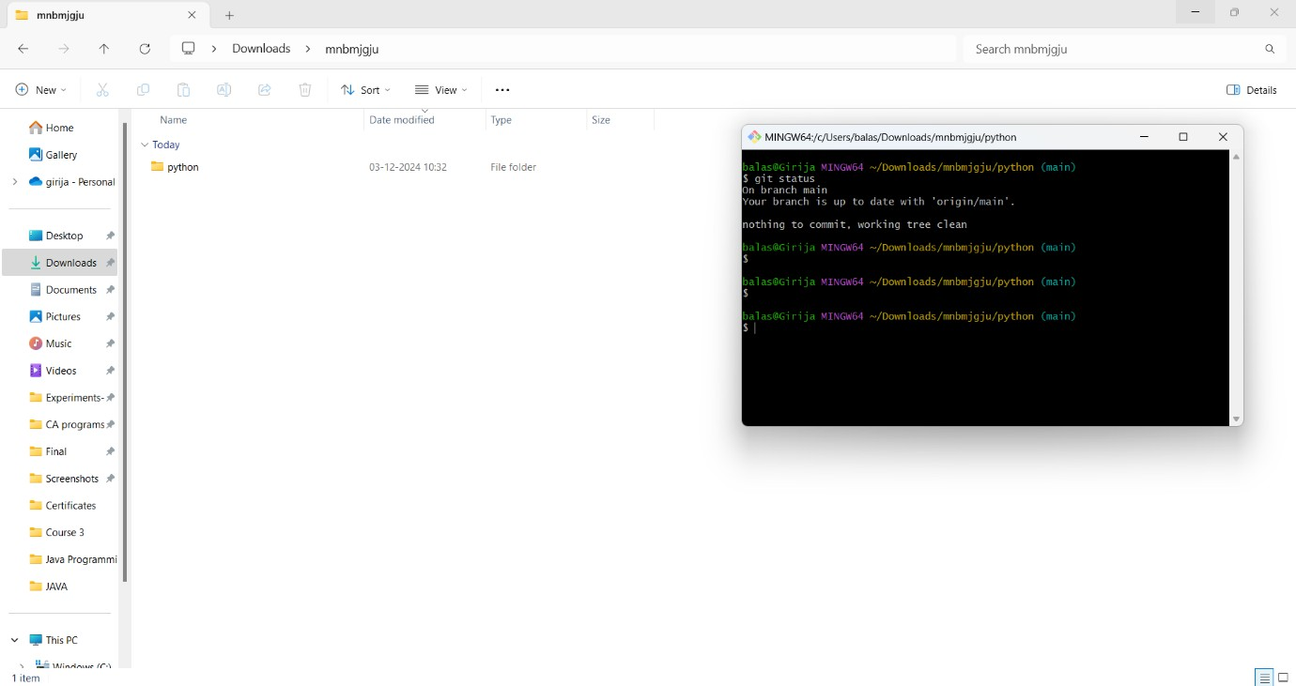

1. 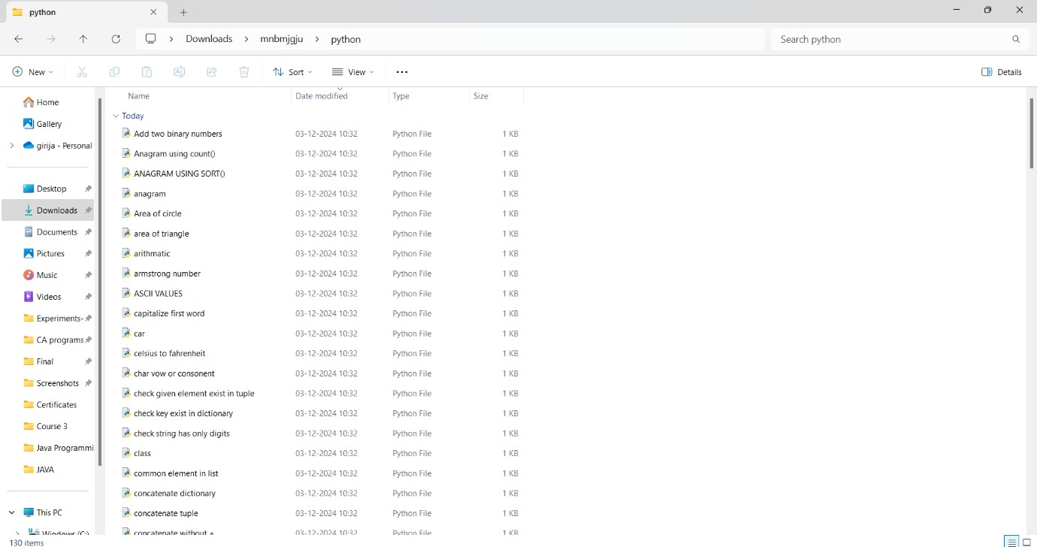Now open the folder copied and verify the cloning.